

|  |
| --- |
| **Final Report** |
| Group Members:  Gurcharan Singh, Jagroop Singh, Harsamerveer Singh, Inderpreet Singh Matharu |
| The Project Final Report is intended to concisely summarize the outcomes of a project and is the final document in the CCS Project Management Methodology. It includes the Brief statement, Scope statement, Project charter, WBS, SMART paper, Milestone report, Gantt chart and Cost estimate. |
| Checklist   * Brief Statement ✔ * Scope Statement ✔ * Project Charter ✔ * WBS – Gantt Chart ✔ * SMART Paper ✔ * Milestone Report ✔ * Gantt Chart ✔ * Cost Estimate ✔ |





|  |  |  |
| --- | --- | --- |
| BRIEF STATEMENT |  | Solution • • • |
| Pamela Smith, daughter of Mr. and Mrs. Smith is assigned as the project manager for the kitchen renovation project.A budget is set aside to complete the project in less than 2 months and the whole project is sponsored by Jay Smith.Handy Group Inc. is hired as the contractor to overlook and proceed with the entire project. |
|  |
| The following document comprises of a ‘Project Charter’ which is a formal and a short document that describes the project in its entity including what the objectives are, how will they be carried out, who the stakeholders are. The document also includes a ‘Scope Statement’ which outlines the project deliverables, identifies the constraints, assumptions and success factors. Furthermore, the report consists of a ‘Work Breakdown Structure’ (WBS) which is a key project deliverable that organizes then team’s work into small manageable sections. It also provides the necessary framework for detailed cost estimating and control along with providing guidance for schedule development and control.  The whole project is about renovating a 35-year-old kitchen of Smith family which includes tearing down the old kitchen and merging it with the old dining room in order to make the kitchen more spacious and give it a modern look. The paint is dull and gloomy and is coming off and there are many stains in the upper corners. The chandelier, cabinets, sinks and tiles need replacing. The windows and sliding door also need to be changed. The old countertop is outdated and needs replacement. |

SCOPE STATEMENT

**Project Title: Kitchen Renovation Project**

**Date:** July 24, 2019 **Prepared by:** Pamela Smith, Project Manager, pamela.smith@oal.com

**Project Summary and Justification**: Jay Smith, Owner oh Handy Group Inc., requested this project to assist the company in meeting its strategic goals. The contract will help the company to flourish and will help the company get new contracts once we do the things in proper time with high success rates. The budget for project is $30,000 with time limit of 2 months. So, it is very important to emphasis on system and regulations.

**Product Characterises and Requirements:**

Contract with Handy group Inc.: This will help the contractor for both competitive and Profitable ways in the market. The good results and advertisement will help in the company’s flourishment.

Building permit: It is the approval given to the company to start their work and the construction site must be inspected both before and after completing construction to ensure that it agreement with the approved building codes.

Final sample:

Full demolition: Basically, disclose to us what number of square feet of clay tile or deck you should be expelled, and we'll furnish you with a forthright statement. Our group will initially give you a free, no commitment quote on your expulsion and, in case your content with the value, we'll begin working immediately!

Countertop installation: You can begin with any area of ledge, yet it's ideal in any case the longest corner segment because different areas regularly join or identify with this piece. Our long area had various fitting difficulties—particularly the corner. To get a precise recorder to the divider here, you must incidentally join the corner.

Tile installation: Certain states of tiles, most clearly square shapes, can be imitated to cover a surface without any holes.

Final clean: Clean the dividers, including the trim. On the off chance that the dividers are recently painted, stick to dry tidying. Unscrew and clean your vents with warm, lathery water.

Full payment: The most widely recognized elective installment techniques are platinum cards, charge cards, prepaid cards, direct charge, bank moves, telephone and versatile installments, checks, cash requests and money installments

**Project Success Criteria:** Undertaking Success Criteria: we will probably finish this task inside a 2 month for close to $30,000. The undertaking support, Pamela Smith, has accentuated the significance of the task paying for itself inside 2 months after the site is finished. To meet this money related objective, the company must have solid client inputs.

|  |
| --- |
| **Project Title:** Kitchen Renovation Project  **Project Start Date:** August 1 **Projected Finish Date:** September 30 |
| **Budget Information:** The total is $30,000 for this project. |
| **Project Manager:** Pamela Smith, 526 637 2723, [pamela.smith@oal.com](mailto:pamela.smith@oal.com) |
| **Project Objectives:**  Scope: Complete Kitchen Renovation.  Time: Renovation complete in less than 2 months.  Cost: Cost no more than $30,000. |
| **Main Project Success Criterion:** To Complete the project within the budget in 2 months. |
| **Approach**   * Remodel the Kitchen as per Smith family requirements. * More space and various equipment’s are required. * Budget must include estimates for plumbing, electricity, storage cabinets, paint, flooring, celling, sinks, lighting and detailing. * Kitchen layout should be simple and functional for adults. |
| **ROLES AND RESPONSIBILITIES (PARTIAL LIST)** |
| **Name Role Position Contact Information** |
| Jay Smith Sponsor Owner [jay.smith@oal.com](mailto:jay.smith@oal.com) |
| Pamela Smith Project Manager [pamela.smith@oal.com](mailto:pamela.smith@oal.com)  Manager |
| Will Newman Team Handy Group Inc. will.newman@oal.com  Member demolition and assembly |
| Jared Newman Team Handy Group Inc. jared.newman@oal.com  Member cabinet maker |
| Lee Jones Team Handy Group Inc. lee.jones@oal.com  Member title work and painting |
| Jay Newman General Handy Group Inc. jay.newman@oal.com  Contractor Owner |
| **Agreement**: Date: 13 July 2019    Pamela Smith Jay Smith  Project Manager Signature Sponsor Signature |
|  |
|  |
|  |

PROJECT CHARTER

WORK BREAKDOWN STRUCTURE

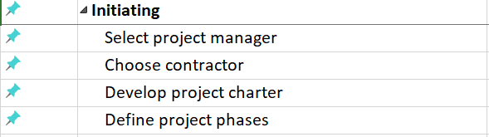

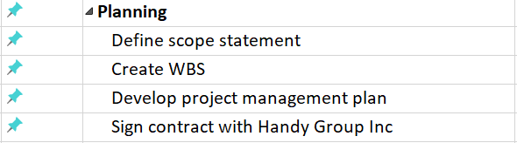



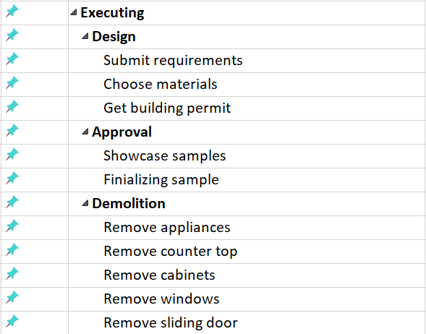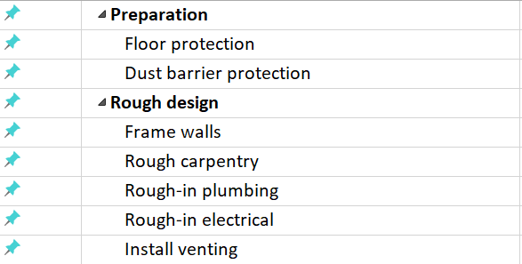

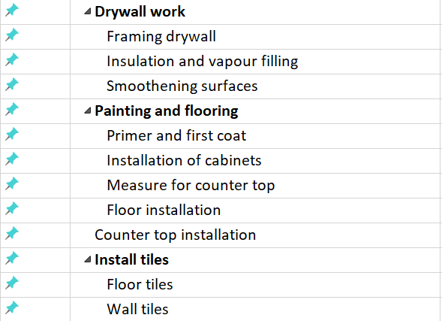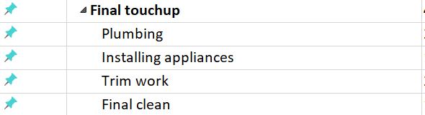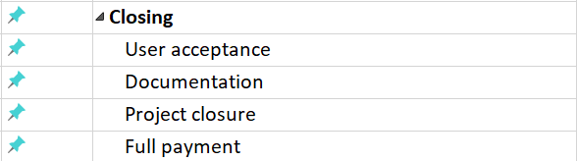

SMART PAPER

Each Milestone Described Using SMART Criteria as follows:

* Specific
* Measurable
* Attainable
* Reliable
* Time Bound

Project Contract Complete

The Project Contract is the one of the first steps to proceed further with this project, it should be signed by owner and contractor with some legal documents.

Kitchen Custom Design

The Plan for the Kitchen renovation is basic need for remodel. The purpose of the redesign is to make Kitchen comfortable and space efficient for Smiths. Development can only be done once there is a plan

Showcase Samples Obtained

The Smiths decision for explicit plan of the Kitchen is required to guarantee fulfillment.

Handy group is best for their work they had many designs in their portfolio.

Demolition Work Completed

The old Kitchen needs to be completely torn down before 18 August in order to start renovation work.

Renovation Permit Approved

Renovation permit is required by law for building new house or renovations to ensure safety and legal housing standards.

Order material Complete

Jay Newman is responsible for ordering material in order to start painting, installing floor and wooden work, for example, cabinets and sinks. It should ready one week before finishing final demolition work

Custom Kitchen Cabinets Made

Kitchen should be flexible with space and more useful cabinets, so its important to order material and appliances according to space available and that should be consulted with the cabinet maker worker.

Painting and Floor Installation Finished

It is the most significant piece of remodel as there should be absolute zero number of errors in this part, owner should be consulting workers what suits best for painting job and its within price range of smiths

Installation of furniture and appliances Finished

Plumbing and electricity is the root step for this part, it should be completed in order to complete this part, moreover the inspection is next step so it should be tested twice while installing appliances.

Inspection Passed

Mr. Smith is responsible for booking appointments for inspection after demolition work is done and again after the plumbing and electricity part is finished.

Approval from Smiths

The objective of the renovation is to renovate the kitchen with another plan that will fulfill the Smiths, therefore the final approval is necessary.

MILESTONE REPORT

|  |  |  |  |  |
| --- | --- | --- | --- | --- |
| **Milestone** | **Date** | **Status** | **Responsible** | **Issues/Comments** |
| Project Contract Complete | 08, August | Completed | Mr. Smith | Complete Project before 2, October 2019 |
| Kitchen Custom Design | 12, August | Completed | Pamela Smith | Submit on time for getting building permits |
| Showcase Samples  Obtained | 16, August | Completed | Mr. Smith,  Mrs. Smith | So that Smiths can finalize their choice. |
| Demolition Work Complete | 30, August | Completed | Will Newman | To approve permits |
| Building Permit Approved | 12, August | Completed | Jay Newman |  |
| Order Material Complete | 22, August | Completed | Jay Newman |  |
| Custom Kitchen Cabinets Made | 13, September | Completed | Jared Newman |  |
| Painting and Floor Installation Finished | 15, September | Completed | Lee Jones,  Jay Newman | So that installing appliances can have some time to test them. |
| Installation of furniture and appliances Finished | 23, September | Completed | Brenda Newman,  Will Newman | Test it twice for inspecting for plumbing and electricity. |
| Inspection Passed | 25, September | Completed | Mr. Smith, Jay Newman and Inspector |  |
| Approval from Smiths | 30, September | Completed | Mr. Smith  Mrs. Smith  Jay Newman |  |
| Project Closure | 30, September | Completed | Jay Newman | Owner is fulfilled and satisfied with work done. |

GANTT CHART

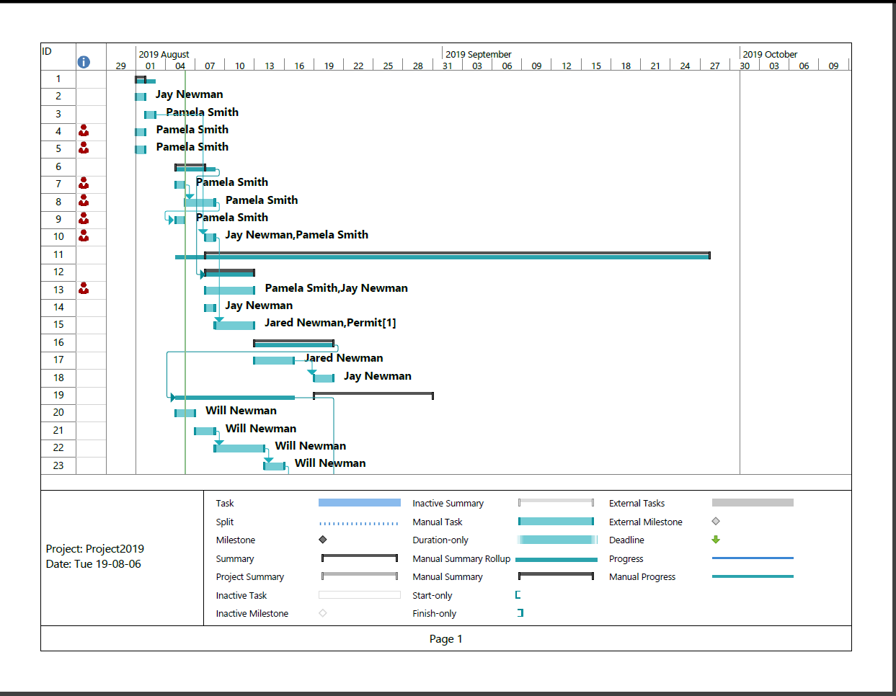

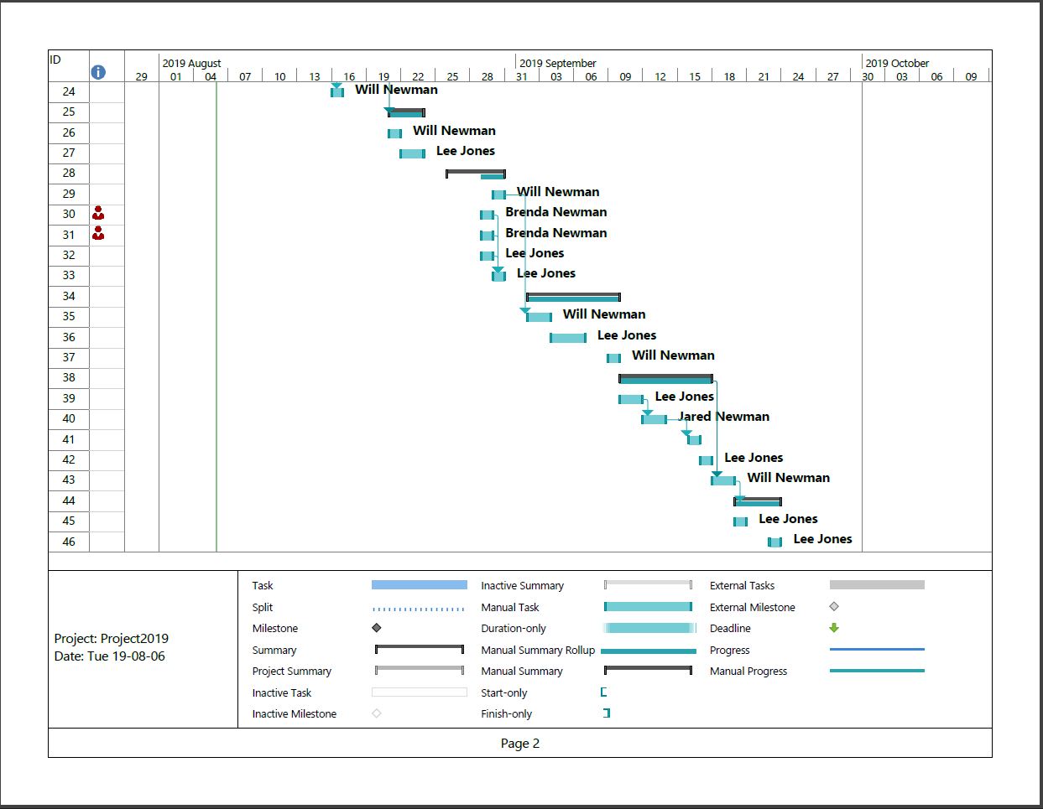

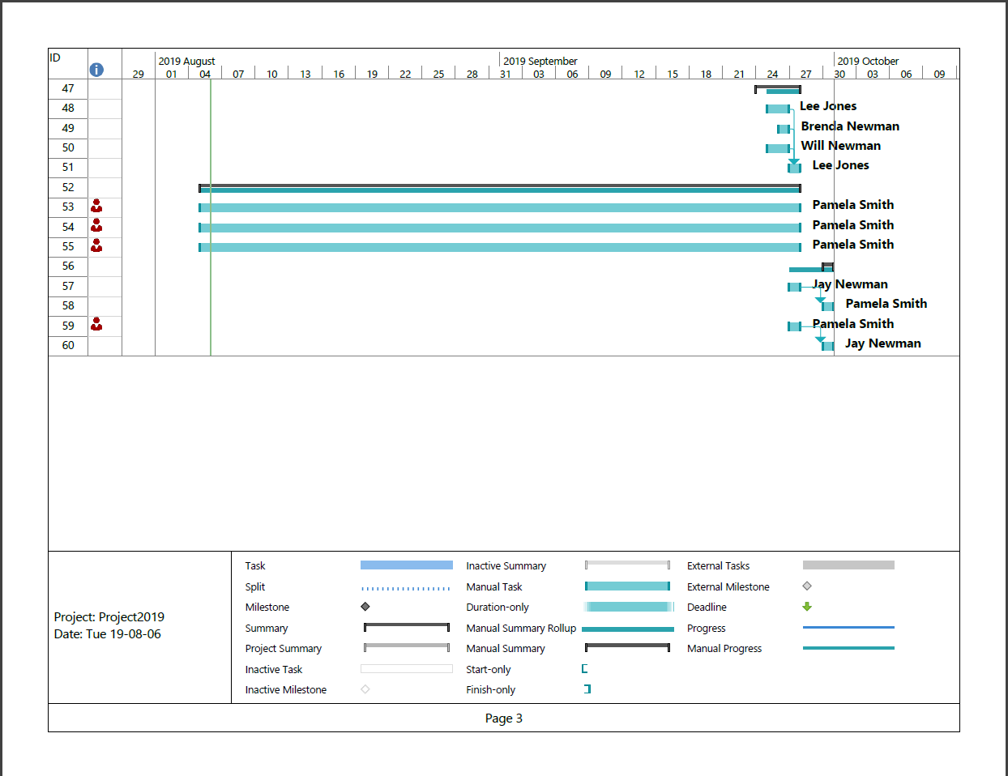

COST ESTIMATE

|  |  |  |  |  |  |
| --- | --- | --- | --- | --- | --- |
|  | Units/Hrs. | Cost/Unit/Hr. | Subtotals | WBS Level 2 Totals | % of Totals |
| WBS Terms |  |  |  |  |  |
| 1. Project Management |  |  |  | **$14,940** | **54.24%** |
| Project Manager | NA | $0.00 | $0.00 |  |  |
| Team Members |  |  |  |  |  |
| Jay Newman | 19 | $120 | $2280 |  |  |
| Jared Newman | 12 | $110 | $1320 |  |  |
| Brenda Newman | 09 | $90 | $810 |  |  |
| Will Newman | 72 | $90 | $6480 |  |  |
| Lee Jones | 54 | $75 | $4050 |  |  |
| 1. Material |  |  |  | **$5700** | **20.70%** |
| Sink | 1 | $100 | $100 |  |  |
| Window | 2 | $350 | $700 |  |  |
| Sliding Door | 1 | $700 | $700 |  |  |
| Paint |  |  | $800 |  |  |
| Floor Tiles |  |  | $900 |  |  |
| Wall Tiles |  |  | $700 |  |  |
| Countertop | 1 | $400 | $400 |  |  |
| Chandelier | 1 | $200 | $200 |  |  |
| Dry Wall boards |  |  | $1200 |  |  |
| 1. Carpentry |  |  |  | **$5900** | **21.42%** |
| Rubber wood boards | 7 | $700 | $4900 |  |  |
| Accessories |  |  | $1000 |  |  |
| Miscellaneous |  |  | $1000 | **$1000** | **3.63%** |
| Total Cost Estimate |  |  | **$23900** | **$27540** |  |